Java Assignment -roshini(192321167)

1.

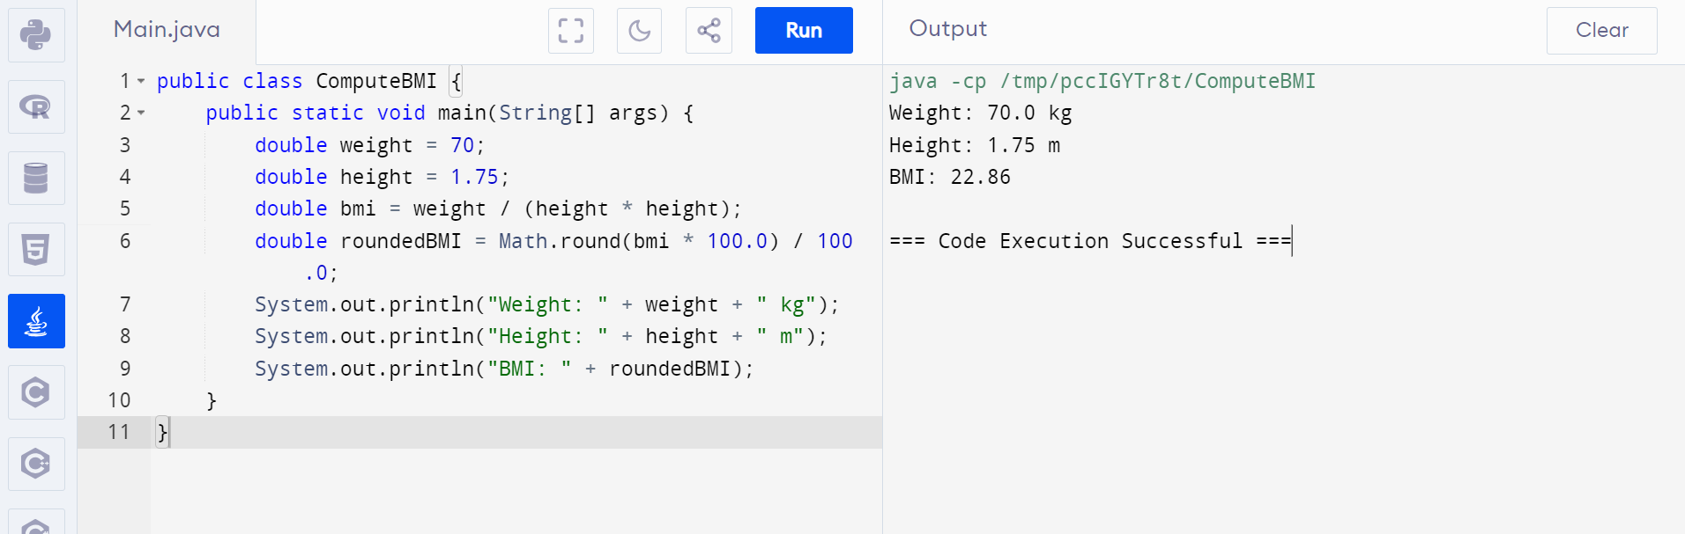

2.

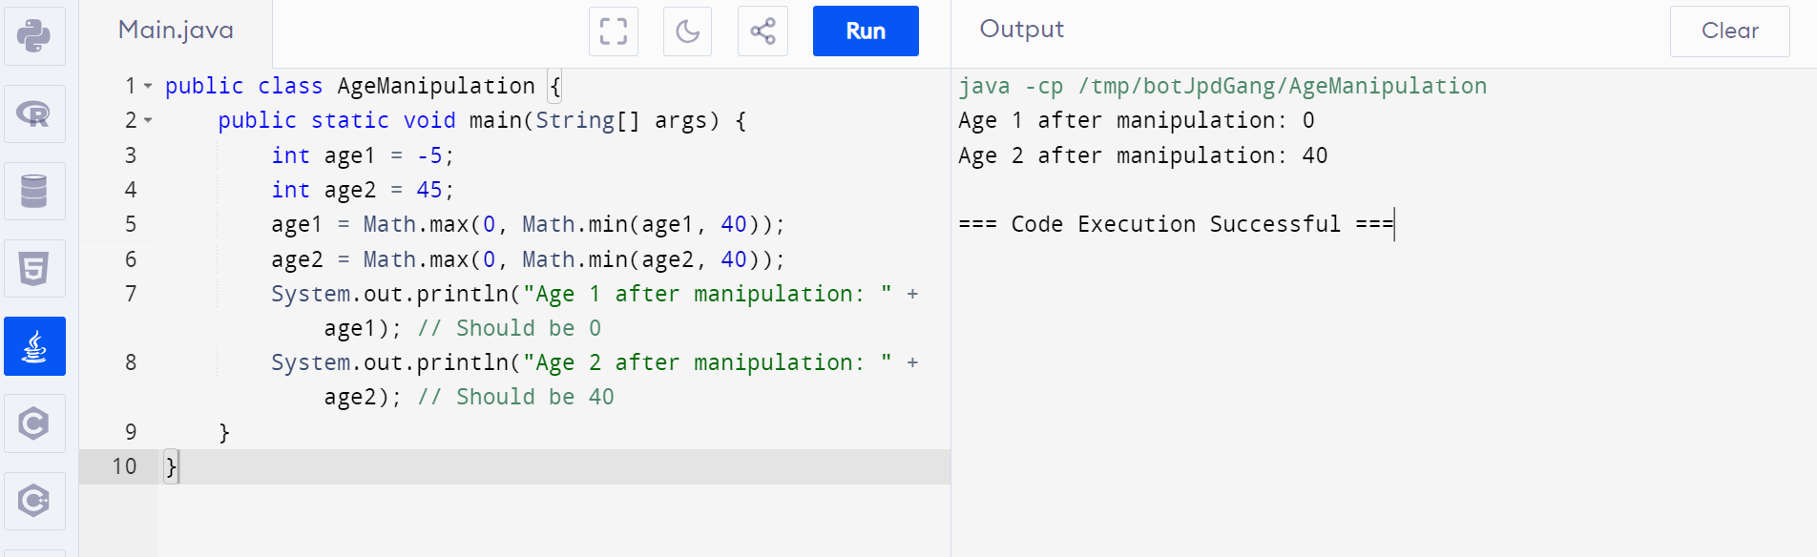

3.

